Sharlston Rovers Juniors new subscription payments September 2018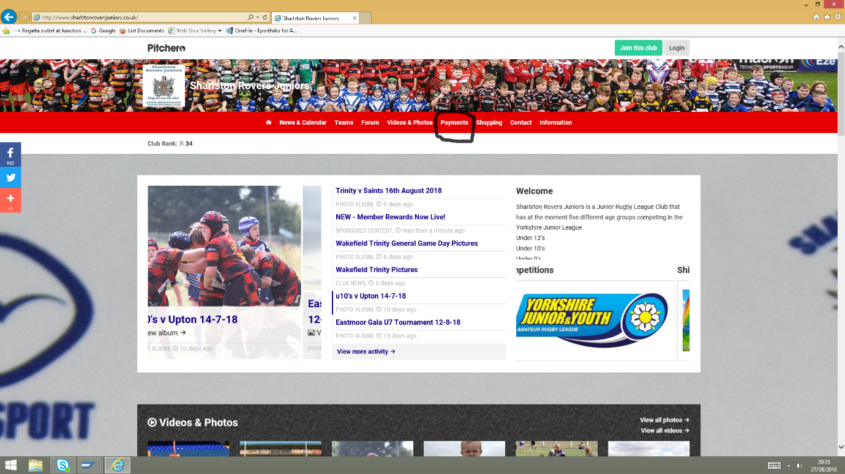Go to www.sharlstonroversjuniors.co.uk and click on payments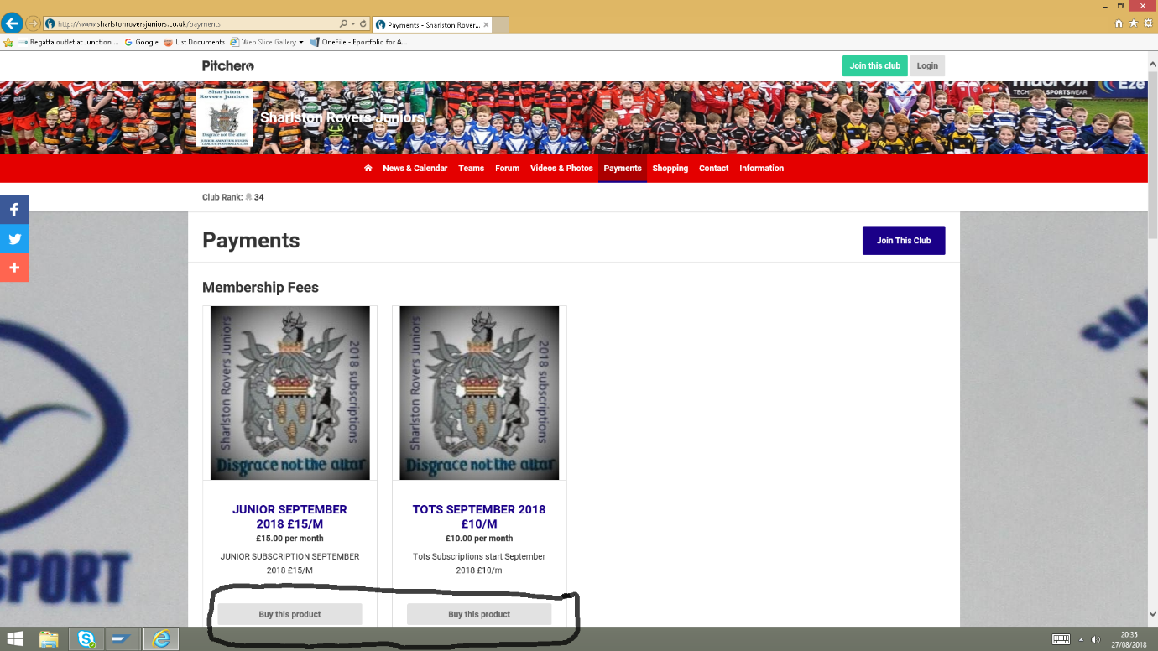click on the product you require either Juniors or tots and Buy this product
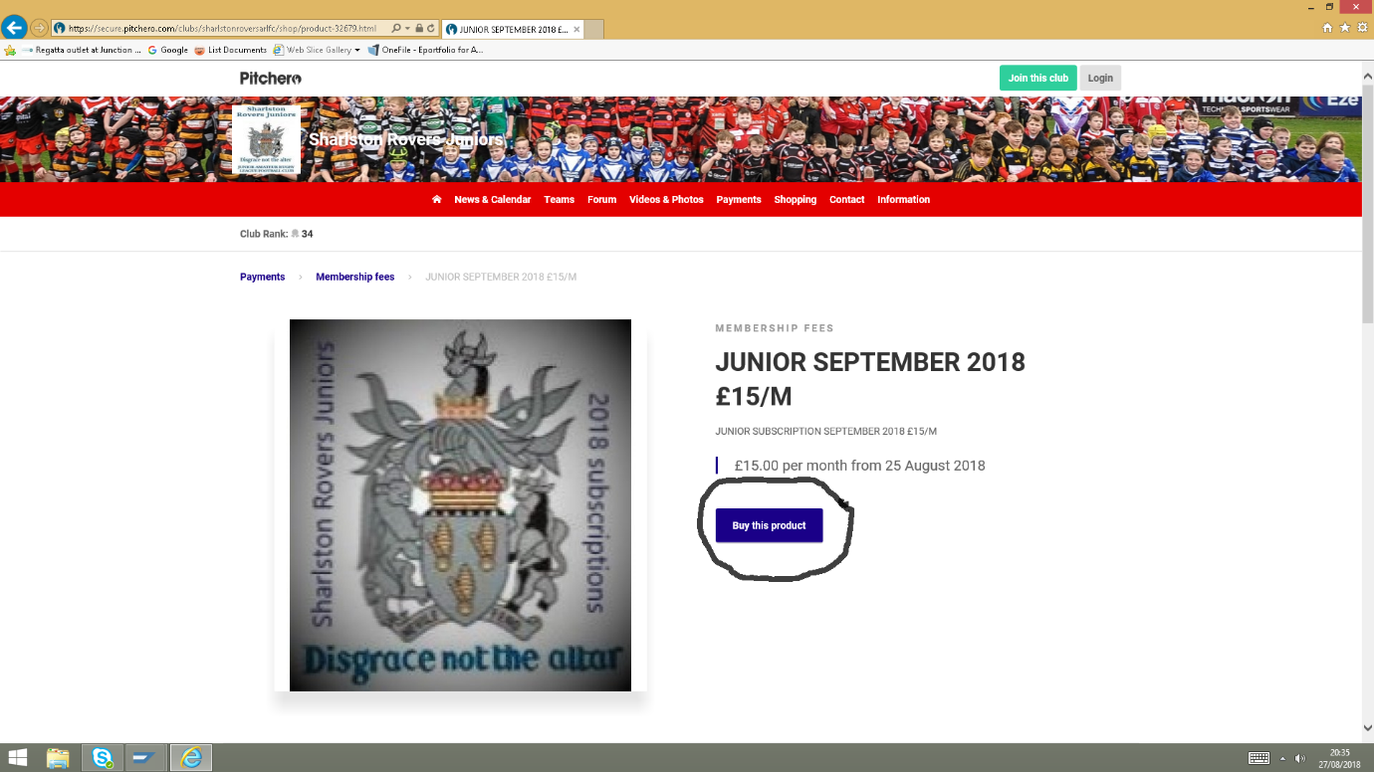
Click Buy this product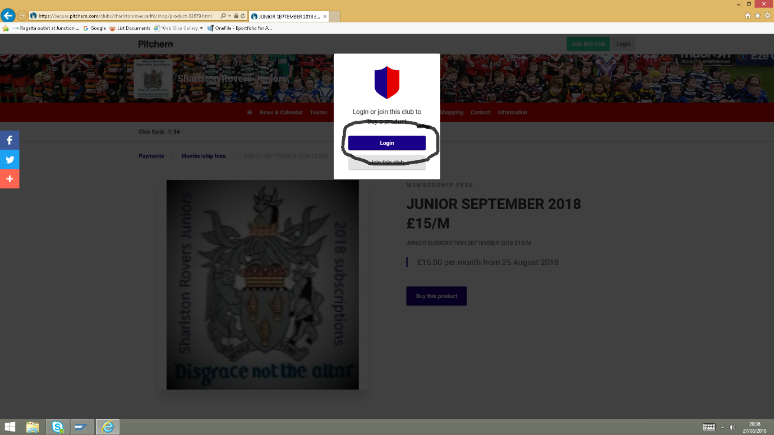
Login to your accout
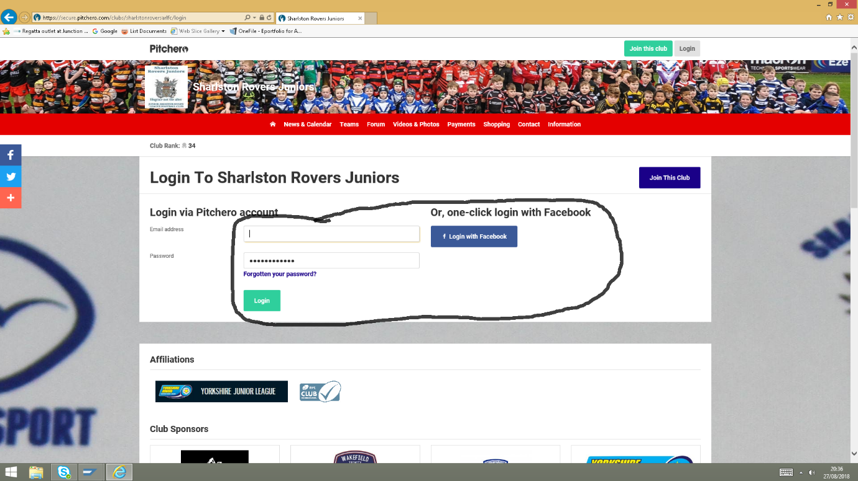
Enter your email & password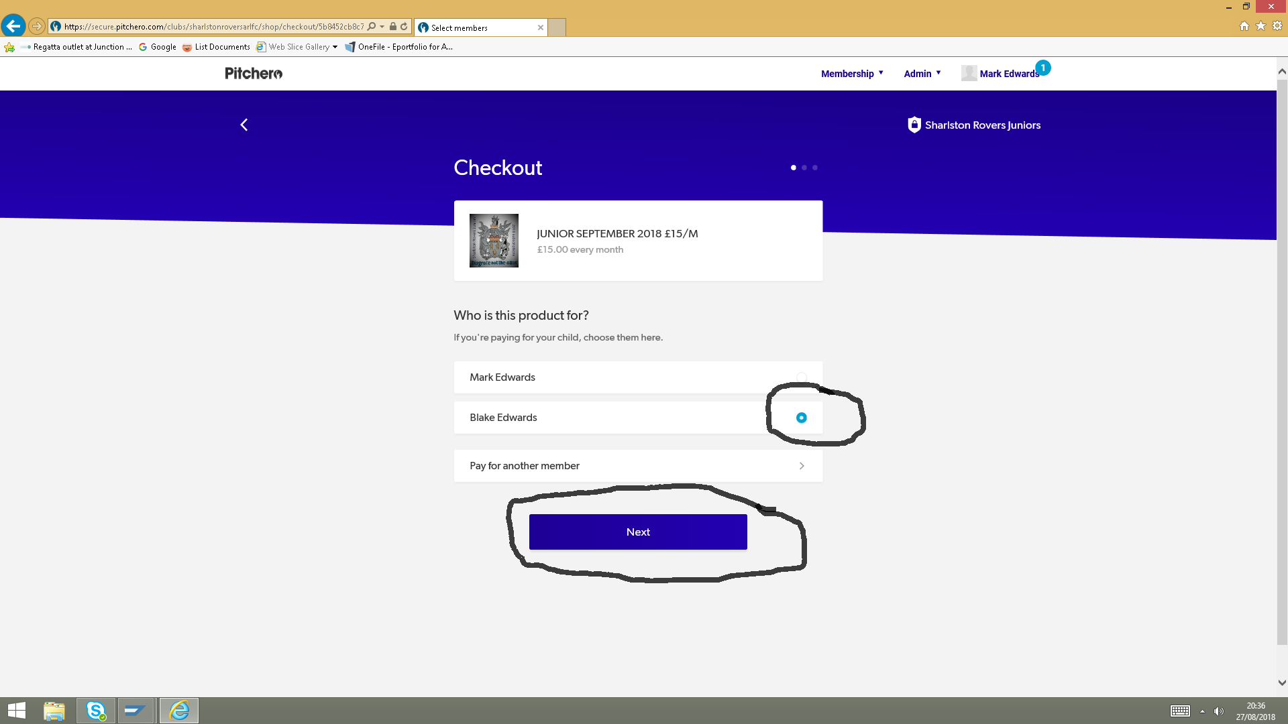
Pick the child’s name you are paying for if you have more than one playing you will have to do it all again for the other child
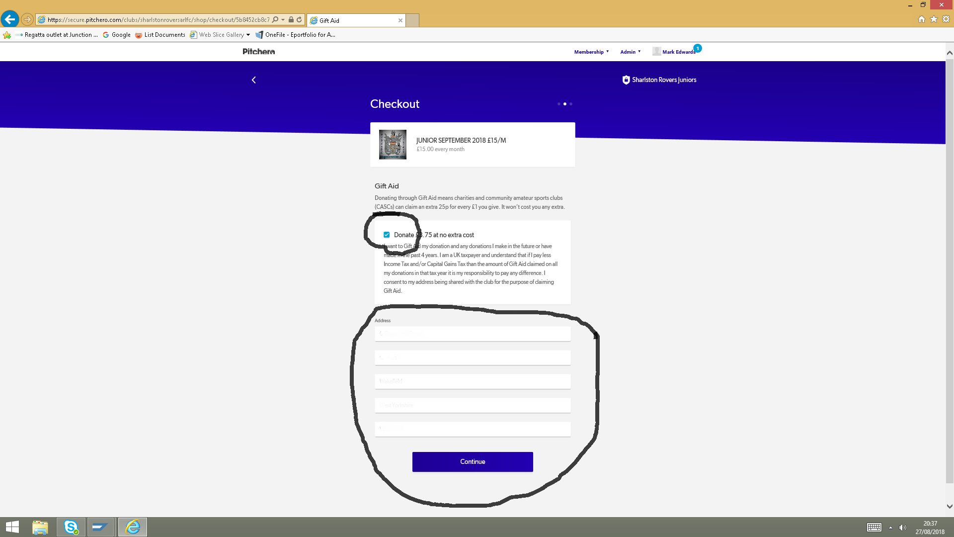
Please click the gift aid box
Fill in your details and continue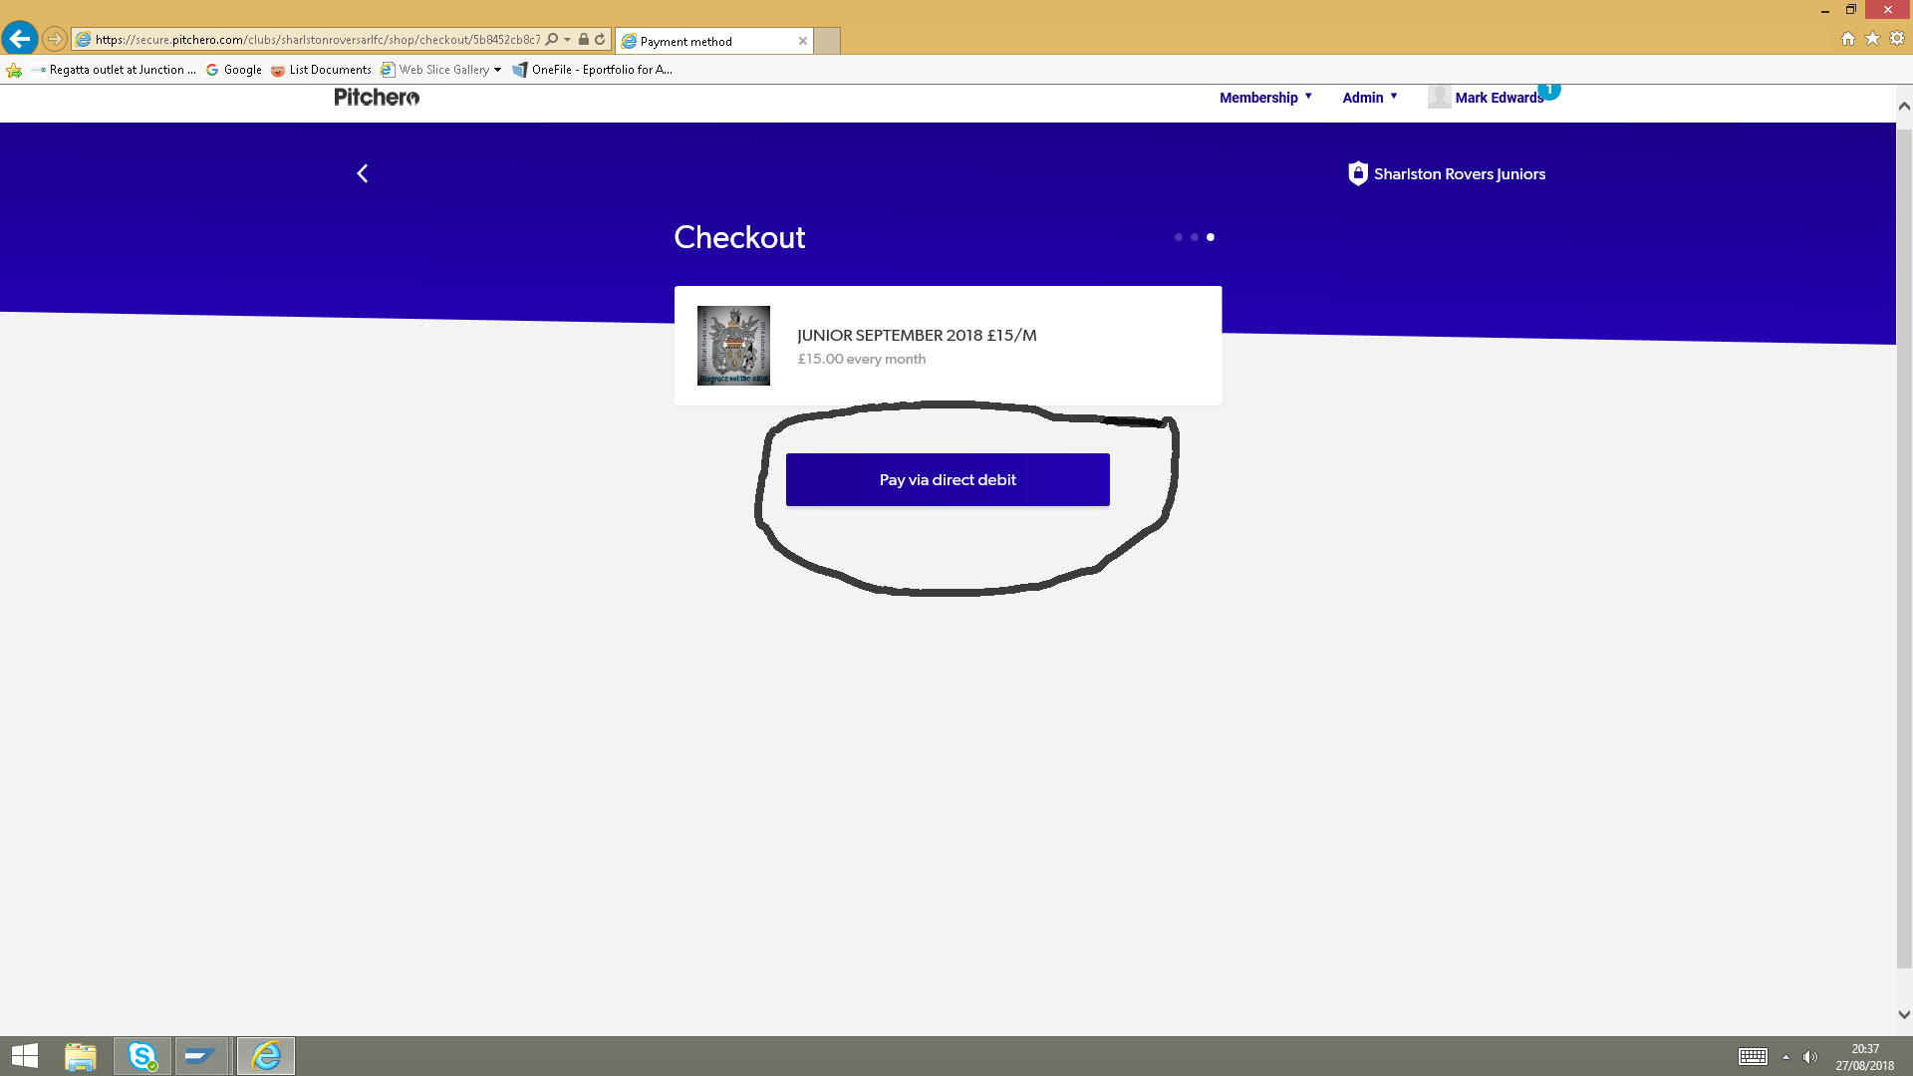
Click Pay via direct debit and you will be directed to our payment provider go cardless
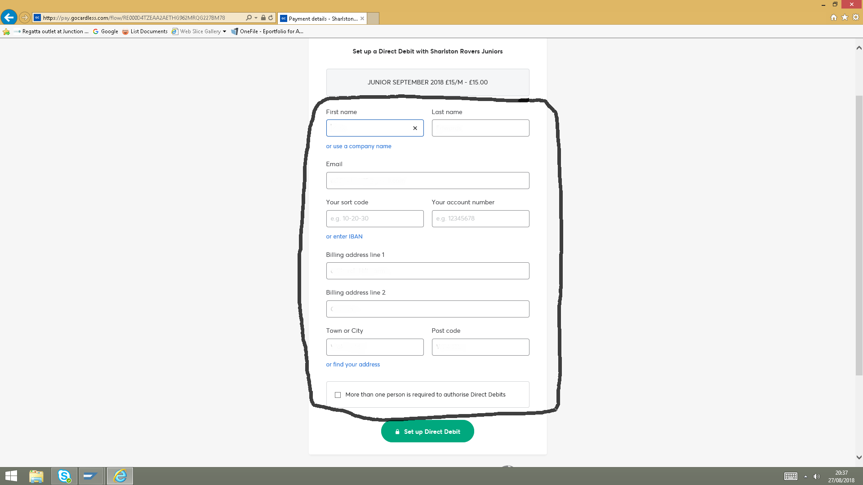
Fill in your details Name, Email, Sort code, Account number, address and click set up Direct debit and confirm
All Done

